1. Find the number of students who scored less than 5(50%).

First I filtered the data who scored less than 50% using FILTER function and using COUNT I found the number of students who scored less than 50%

1. List the name of students who are from Alaska.

By using filter function I filtered the state and generate name for the respective .

1. How many government colleges are there in Alabama?

In this we have to filter both college and state. So I first filtered college and state. Then I count the name using count function

1. List the name of students who are from Oregon and pursuing BE.

Here we have to find students from Oregon and pursuing BE.So I was filtered state and stream.

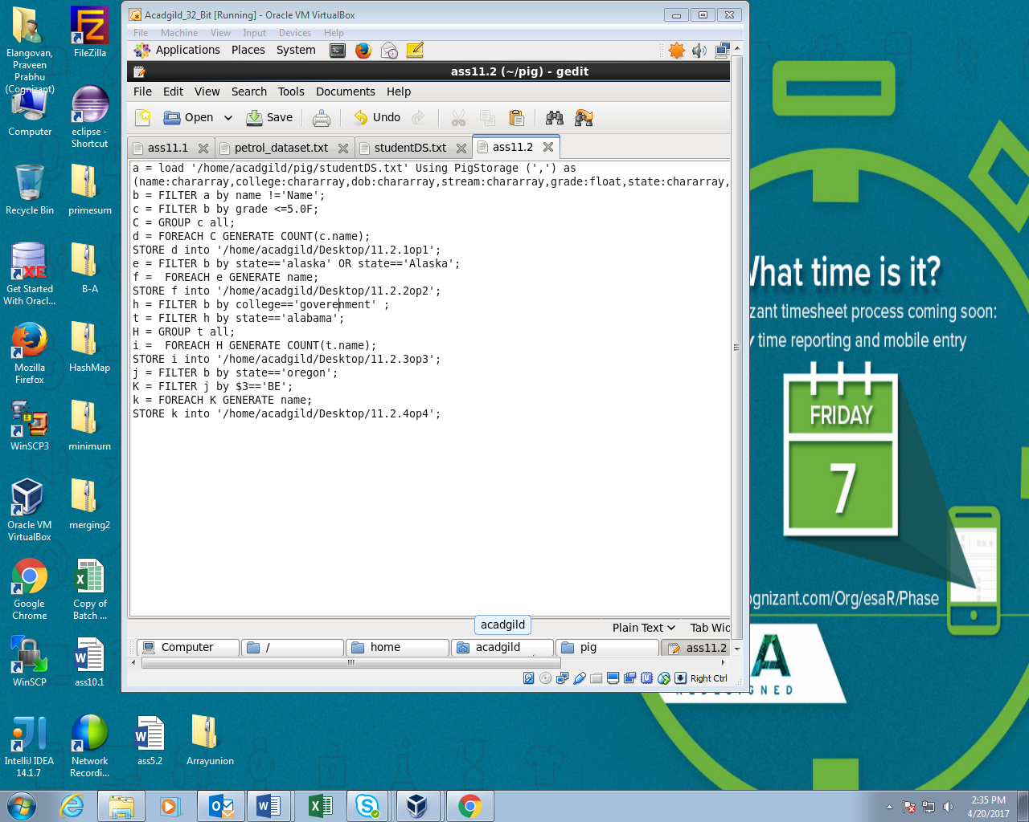

Running PIG Script:

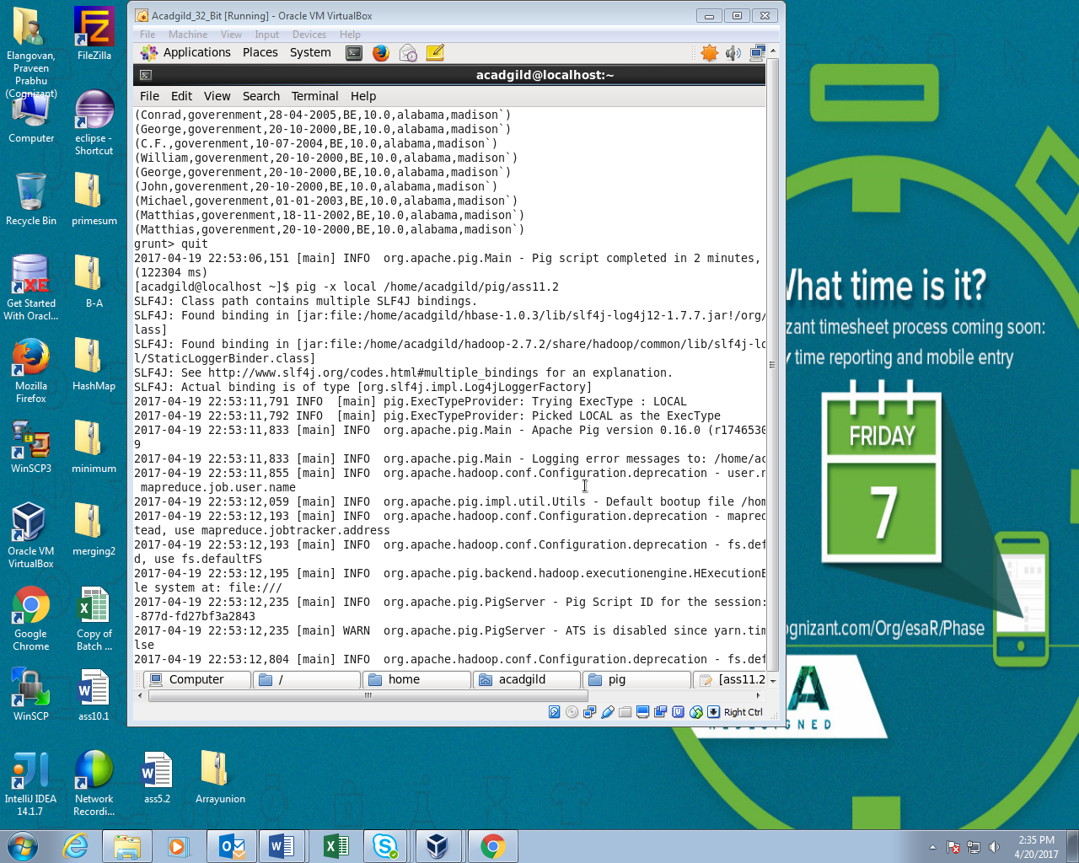

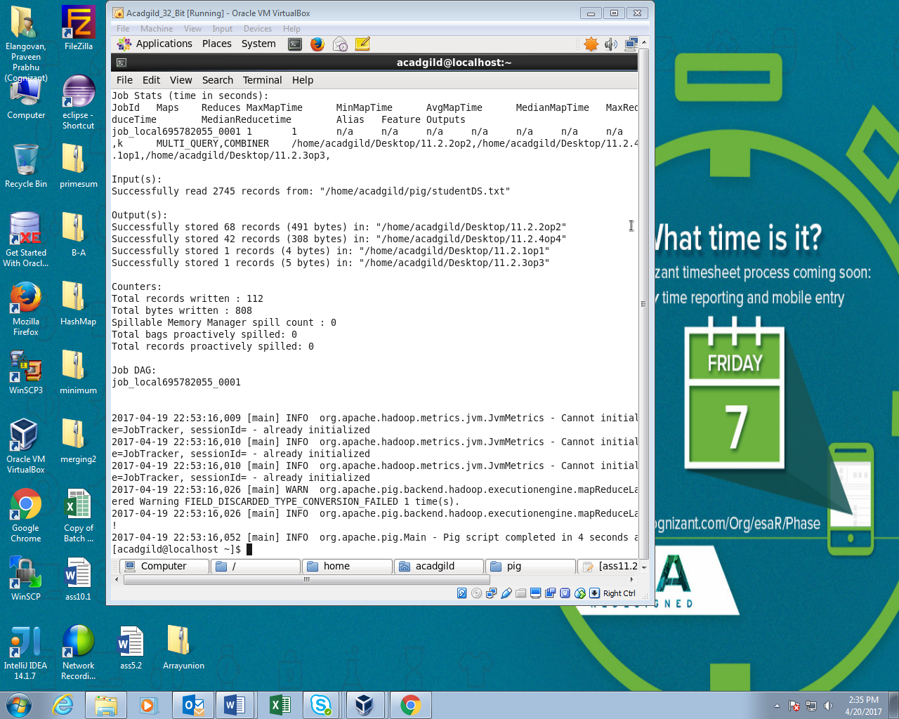

OUTPUT:

